Variation on a Classic Theme - Standard
Mike Long
Before Invasion, you probably paged through your collection and realized the same thing I did: without Urza's Block Standard will be vastly different. Some folks think Standard will look just like Masques Block Constructed (MBC) plus Vampiric Tutors and Crusade. Others see Ernham-geddon making a comeback, with Blastoderm and Jade Leech in the role of 300-pound gorilla.

Put enough monkeys at typewriters, and eventually they'll write: "I win."
Will Mercenary decks and Rising Waters dominate the new Standard? What about old school favorites like fatty-geddon and White Weenie?
I think it's worthwhile to wade in and look at new versions of classics, so I built updated versions of six decks from MBC and earlier and did some testing. Fatty-geddon, Rising Waters, and Nether-Go were the standouts. My early favorite was Ponza, but it got wrecked by Tsabo's Web and Teferi's Response. I set it aside for a major rebuild.
Tried and true is tried and true, and you can expect classic revisions to make up the body of Standard for a few weeks at minimum. It's important to realize that until a new set has seen a lot of play, even obvious winners spend time on the bench. Jade Leech and Kavu Titan are clearly solid, but Blastoderm and River Boa are veterans, and for the purposes of this article, we're starting only first-round rookies.
Rising Waters
Main Deck |  | Sideboard
2 Waterfront Bouncer  4 Cloudskate  4 Rishadan Airship  4 Chimeric Idol  4 Troublesome Spirit  2 Air Elemental  4 Daze | 4 Thwart  4 Foil  2 Rising Waters  4 Gush  4 Rishadan Port  18 Islands
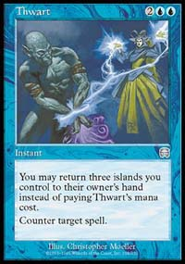
I tried to update the Blue Skies deck that was so popular in the Masques Block qualifiers and this is what I came up with. Almost all of the cards from the deck are from Masques block and it is disappointing not to take advantage of 6th edition or Invasion, but it's still a pretty good deck. It really takes advantage of the Gush/Foil/Thwart engine and its mana works out pretty well.
In play: This deck is pretty quick and once it gets an advantage it's tough to take the game away from it. Still, it is a bit inconsistent with temperamental creatures that don't always come up when they should. What the deck really misses is something like Morphling or Masticore to make it great.

Green White
Main Deck |  | Sideboard
3 Llanowar Elf  4 Ramosian Sergeant  3 Fresh Volunteers  4 River Boa  4 Chimeric Idol  4 Blastoderm  3 Saproling Burst  3 Wax and Wane | 4 Tangle Wire  4 Parallax Wave  2 Armageddon  3 Rishadan Port  4 Elfhame Palace  4 Brushland  6 Forest  5 Plains
The good news about this deck: if you haven't picked up much Invasion, you probably still have the cards to play it. The only fresh tech that made the cut is Elfhame Palace and Wax/Wane, though both Kavu Titan and Jade Leech auditioned well. Though the Leech often seems better than Blastoderm, I'm sticking with the Parallax Wave-resistant 'Derm.
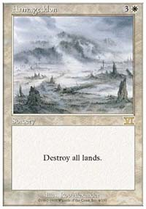
This is more or less an update of Ben Rubin's Top 4 Green/White Rebel deck from Pro Tour New York. It was a good deck then and is nicely curved by early pressure from River Boa, a small Rebel chain and Chimeric Idol. Trading Disenchants for Wax/Wane tests really well, especially given how many targets abound for Giant Growth-it will never be a dead card. Note that this deck resembles White Weenie more than the controlling Ernham-geddon decks of years past.
In play: fatty-geddon creates an early advantage with two and three drop creatures that hit hard, frustrates opponent's early efforts with Tangle Wire and Parallax Wave, then puts the game out of reach with hard-hitting Blastoderms and Saproling Bursts. The seven rebels are quirky, but are almost always solid and sometimes devastating. The tweak that put the deck over the top, though, is swapping Kavu Titans for Chimeric Idols. A 3/3 for 3 that resists sorcery removal (and Teferi's Moat) makes all the difference in the world.
Grade A-
Nether-Go
Main Deck |  | Sideboard
4 Chimeric Idol  3 Nether Spirit  4 Opt  2 Tsabo's Web  4 Counterspell  4 Recoil  3 Thwart | 4 Foil  4 Fact or Fiction  3 Bribery  2 Dominate  4 Underground River  4 Salt Marsh  15 Islands
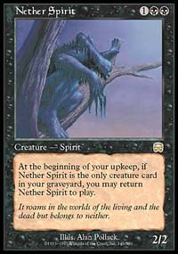
Ben Rubin's MBC original had a disappointing debut at Worlds but showed a lot of promise. The first version used several black removal spells. This deck replaces them with deck motion: Opt and Fact or Fiction. (A side note, these two are good indicators that Wizards is hard at work on new cool and useful card design.) Fact or Fiction, Foil and Recoil have a nice bonus: free Nether Shadows in the graveyard.
In play: Nether-Go stalls until it can drop a Nether Spirit into the graveyard, and then it stalls some more. Did I mention it's a stall deck? It often seems like it will never win but ultimately took over 60% of its games. Frustrating combos like Fact or Fiction/Foil/Nether Spirit mix with non-combos like Counterspell/Chimeric Idol. Still, the Idols serve necessary beats and help the deck more than they hurt. A surprising MVP is Recoil--often a three drop Desert Twister. With some work this construct might be a killer.
Grade B+

Sleeper Deck: Mercenaries
Main Deck |  | Sideboard
1 Vampiric Tutor  4 Dark Ritual  4 Vendetta  4 Cateran Summons  4 Rampart Crawlers  1 Molting Harpy  4 Cateran Persuaders  1 Agent of Shaku  2 Spineless Thugs | 4 Rathi Intimidators  1 Rathi Fiend  4 Unmask  4 Snuff Out  3 Dark Triumph  1 Deleraich  16 Swamp  2 Rishadan Port
This is a scanty update of Tommi Hovi's MBC beast from Worlds. It is a surprisingly dangerous; look out if it draws Dark Ritual. The lone 6th edition enhancement is one Vampiric Tutor. (If Bad Moon was in 6th, this deck would be a power to behold.) You just have to pray that your opponent doesn't have Light of Day.
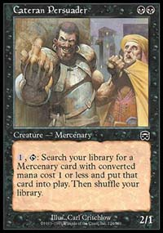
In play: the Mercenary deck relies on 4 Persuaders, 4 Intimidators and 4 Cateran Summons for pressure and card economy while the other elements stave off the opponent. Unmask proves there is life after Duress-it's the best non-creature card in the deck. The Dark Triumphs are cheesy but effective, and Vendettas and Snuff Outs complement Mercenary search with low casting costs. Frustrating as it sounds, Mercenaries wins more than it loses and almost never fails to beat a Counter deck. Bad hangover the day of States? This is yer dawg. Put enough monkeys at typewriters, and eventually they'll write: "I win."
Grade B-
These decks are a start, but really they're the vestiges of days gone by. As new sets hit the Block, more Invasion cards will see play, and new decks will peek from behind the curtain. But until then, expect to see a lot of "new and improved."
Classic is classic after all, but I really look forward to the Invasion of new archetypes and new perspectives on deckbuilding. In the next installment, I'll be looking at new designs for States.

